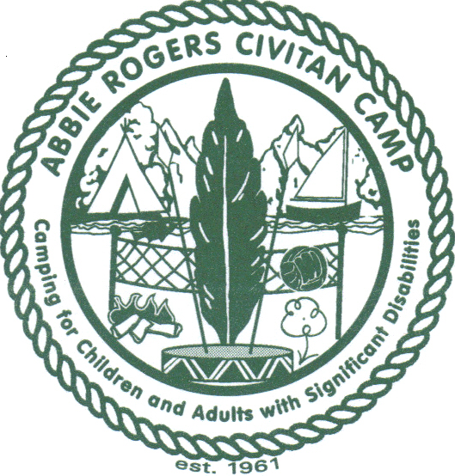
Abbie Rogers Civitan Camp
…a camping experience for children and adults with disabilities

Abbie Rogers Civitan Camp is a nonprofit, all volunteer operated camp in South Mississippi, dedicated to promoting and encouraging recreation and camping activities for children and adults with significant cognitive disabilities (in south Mississippi). Founded in 1961 by Abbie Rogers, the camp continues her life’s work.

Facts:
- Abbie Rogers Civitan Camp is sponsored by the Hattiesburg Civitans and serves children and adults with intellectual disabilities.
- Directed by Terri Daniels (601-447-1649) and Chris Potin (601-520-3209)
- Camp sessions are held each summer for 2 weeks at Camp Iti Kana in Wiggins, MS and one long weekend for adults with disabilities in the Fall.
- Each summer approximately 190 children and adults with disabilities attend the camp.
- Each fall approximately 50 adults with disabilities attend the camp.
- Each year there are approximately 140 teenage volunteer counselors from the Pine Belt area and 120 volunteer staff members who operate the camp.
- The camp is operated solely on donations by individuals and businesses in the Hattiesburg and surrounding communities and is operated by volunteer directors and an all volunteer staff.
- Operation costs per year for approximately $65,000.00. Costs would be higher without the generous contribution of goods from local businesses and individuals.
- 2025 marked the 64th year of camp!
- The Abbie Rogers Civitan Camp tax identification number is 72-1387232
- Office Mailing Address: Abbie Rogers Civitan Camp, 50 Fieldstone, Hattiesburg, MS 39402

There are good times and there are great times—but experiences at Abbie Rogers Civitan Camp surpasses mere words. Most people closely affiliated with camp find it impossible to convey to others why the experience grips so many people and how it changes us for the better. From the day’s beginning with “Oh What a Beautiful Morning” to the end of the day with prayers and “Amen” —there is no doubt that all who are involved in this camp are touched in many ways.

Abbie Rogers Civitan Camp: friendships made, character built, and lives positively changed!

