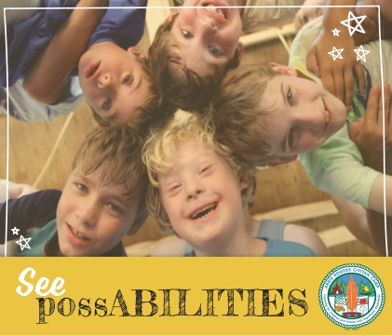

**ABBIE ROGERS CIVITAN CAMP**

www.AbbieRogersCivitanCamp.org

…summer camping for children and adults with significant disabilities

held at the Hattiesburg Girl Scout Camp in **July & October 2017**

Grocery, Target, and Wal-Mart Gift Cards

Spray all-purpose cleaner

Liquid washing detergent

**Heavy duty/sturdy** disposable plates

Red solo cups

Disposable cups (any size)

HP ink 934 or 935

1lb bags of coffee

Salad dressing (any)

Healthy **individual** serve fruit juice boxes/bottles

**Heavy duty/sturdy** plastic spoons, forks

Paper napkins

Pool Noodles

Zip lock gallon bags

Zip lock quart bags and sandwich bags

XL heavy duty garbage bags



